Lesson 7 Demo 3
Creating a Docker Image
Objective: Create Docker Image using Dockerfile

Tools required: Docker Configuration

Pre-requisites: Ubuntu Configuration, Docker

Steps to be followed:
- Creating the Dockerfile
- Executing the Dockerfile

Step 1: Creating the Dockerfile
1.1 Create a directory
mkdir demo
cd demo
1.2 Create the Dockerfile
vi Dockerfile

1.3 Add the following code snippet to the Dockerfile
FROM ubuntu
RUN apt-get update
RUN apt-get install -y nginx
COPY index.nginx-debian.html /var/www/html
CMD nginx -g 'daemon off;'
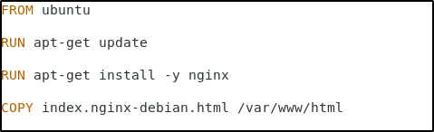

Note: After writing the above code in the Dockerfile, press ESC button and enter “:wq” to save the file and exit the editor.
1.4 Create another file in the same directory
vi index.nginx-debian.html
1.5 Add the following welcome message to the index file
WELCOME TO NGINX.
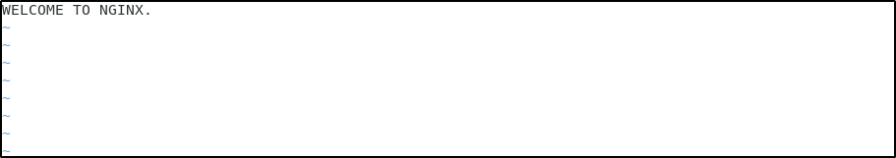
Note: After writing the above code in the html file, press ESC button and enter :wq to save the file and exit the editor.

Step 2: Executing the file
2.1 Execute the Dockerfile (note that there is space between build and “.”)
sudo docker build .
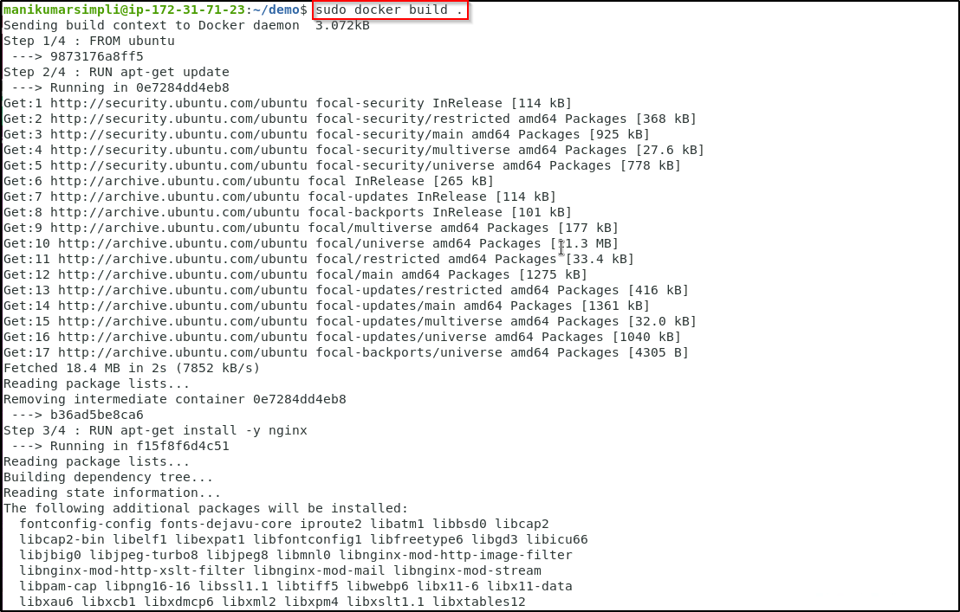
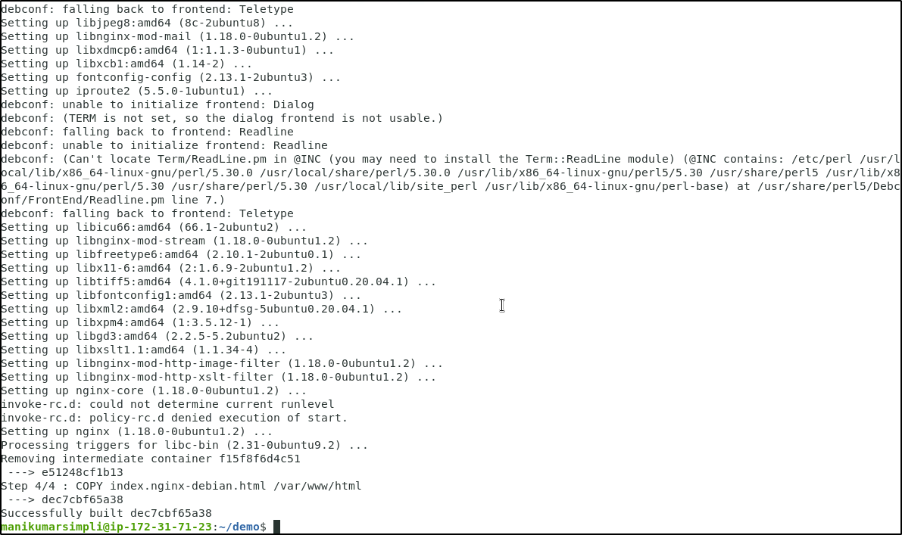

2.2 Navigate to the root folder, and list the images to check the newly created Docker image
cd
sudo docker images
